HOSTEL FEE MANAGER
@CREATIVITY THINK (9483175986/7019689991)

ABSTRACT:
The Hostel Fee Manager is a web-based application designed to automate and streamline hostel fee collection, student profile management, payment reminders, and receipt tracking for colleges and student housing facilities. Students can easily manage their fee payments, view receipts, and track their payment history, while administrators can monitor all financial transactions, send reminders, and access dashboard analytics for payment trends. Built using Django and Django Rest Framework for backend processes and React with axios and Recharts for frontend functionality, the system provides a secure, efficient, and user-friendly solution for centralized hostel fee management..

INTRODUCTION OF THE PROJECT:
Managing hostel fees manually through registers or spreadsheets often leads to errors, loss of data, and delays in payment tracking. Institutions struggle to maintain accurate records, send timely reminders, and generate structured financial reports. Students also face difficulties in tracking due dates and retrieving receipts. The Hostel Fee Manager resolves these challenges by offering an automated platform for fee collection, reminders, digital receipts, and analytics dashboards. This project enhances transparency, reduces administrative workload, and ensures efficient fee management for both students and administrators..

PROJECT OBJECTIVES:

• Provide a centralized platform for managing hostel fee payments
• Enable students to receive automated due reminders and notifications
• Maintain complete digital logs of fee receipts and payment history
• Offer administrators a dashboard for financial analytics and trends
• Ensure secure and accurate handling of student payment records
• Automate receipt generation and student-wise payment tracking
• Reduce manual workload through structured digital management
• Improve transparency and efficiency in hostel fee operations

PROBLEM OF THE STATEMENT:
Traditional hostel fee management relies heavily on manual processes, paper receipts, and inconsistent tracking methods. This leads to errors in fee records, missed reminders, difficulty in retrieving receipts, and a lack of comprehensive financial analysis. Administrators face challenges in monitoring due payments and generating timely reports. Students also have limited visibility of their payment status. The Hostel Fee Manager addresses these issues by digitizing the entire process, enabling reliable reminder systems, centralizing receipt logs, and providing dashboard analytics for informed decision-making..

MOTIVATION OF THE PROJECT:
• To reduce manual workload for hostel administration
• To provide students with transparent and accessible payment tracking
• To eliminate errors in fee calculation and record keeping
• To ensure timely reminders for due or pending payments
• To create a fully digital, receipt-based fee management system
• To support institutions with accurate financial reporting and analytics

BLOCK DAIGRAM OF PROJECT:

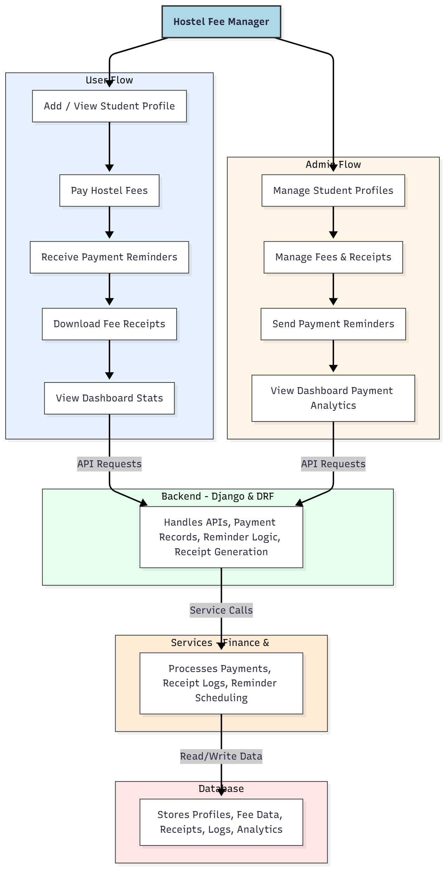

WORKING OF THE PROJECT:
The system begins when a student profile is created or accessed through the interface. Students can proceed to pay hostel fees, after which the backend processes the payment details, generates digital receipts, and stores them in the database. Automated reminders are sent to students for upcoming or overdue payments based on system schedules. The administrator has full access to update fee structures, manage student profiles, review receipts, and monitor payment analytics through the dashboard. The system ensures reliable financial management through automated processes, structured logs, and real-time analytics..

SOFTWARE REQUIREMENT:
- Backend:
  - Python 3.x
  - Django
  - Django REST Framework
  - SQLite/PostgreSQL
- Frontend:
  - Node.js and npm
  - React.js
  - Axios
- Development Tools:
  - Visual Studio Code
  - Postman (for testing APIs)
  - Git/GitHub (for version control)
- Server/Deployment (Optional):
  - Gunicorn, Nginx, or Heroku/AWS for hosting

ADVANTAGES OF THE PROJECT:

• Reduces manual administrative workload
• Automates fee reminders and notifications
• Provides secure and centralized payment tracking
• Maintains digital receipts and payment history
• Offers dashboard analytics for financial insights
• Enhances transparency for students and administration
• Minimizes human error in fee records
• Supports easy access to historical payment data

APPLICATIONS OF THE PROJECT:
• College hostels
• University student accommodation
• Private hostels and PG facilities
• Student housing management companies
• Residential training institutes
• Boarding schools
• Government hostel administration systems

REFERENCES:

- Django REST Framework Documentation — Django Software Foundation. Django Documentation. Available: https://docs.djangoproject.com/
- Django REST Framework. DRF Documentation. Available: https://www.django-rest-framework.org/
- React. React Official Documentation. Available: https://reactjs.org/docs/getting-started.html
- Redux. Redux Documentation. Available: https://redux.js.org/introduction/getting-started
- PostgreSQL Global Development Group. PostgreSQL Documentation. Available: https://www.postgresql.org/docs/
- MySQL. MySQL Reference Manual. Available: https://dev.mysql.com/doc/
- Git. Git Documentation. Available: https://git-scm.com/doc
- Node.js. Node.js Documentation. Available: https://nodejs.org/en/docs/
- Axios. Axios Documentation. Available: https://axios-http.com/docs/intro
- Socket.io Documentation – https://socket.io/docs/

